East Coast Academy
Inspiring academic excellence since 1862

June 20, 2012

Dr. David Carbonara
Duquesne University
600 Forbes Avenue
Pittsburgh, PA 15219

Request: Funds for Technology Resources

Dear Dr. Carbonara,

East Coast Academy School District is happy to present you with a proposal for updated technology resources. St. Paul's school has over 300 students who are currently at risk in their assessment performance due to lack of up to date resource and classroom engagement.

East Coast Academy is dependent on funds from very few sources such as parents, alumni and other foundations. Since we are low on funds we are still not in a financial situation to completely update curriculum resources.

East Coast Academy appreciates your assistance in helping us to achieve our modest objective. Our proposal requests $30,000 to arrange the necessary equipment and training for all faculty members. We request you to help our school and students. In case you wish to inquire or have a meeting with school authorities, you can contact us on the number (631-276-0975) between 7am to 4pm or you can email us at eastcoast@gmail.com. We look forward for a fast reply.

Sincerely Yours,

Ms. Ariel M. Myers
Technology Coordinator
East Coast Academy

Summary

East Coast Academy seeks $29,169.00 to fund new updated technological resources for students in our K-12 school district. The new resources will benefit the learning of 2,000 children and teenagers annually, providing them access to thousands of Web 2.0 applications, databases, e-books, online libraries and more.

Introduction

The East Coast Academy 2012-2014 Technology Plan is hoping to successfully plan, implement and maintain, and continually evaluate the effective and efficient use of technology in our school. The technology plan was created to create a technology committee, improve upon data collected from students and faculty, plan and implement an action plan, recognize critical issues and their solutions and evaluate the technology plan. The three-year goal is centered around meeting our goals of student development, staff development, technology acquisition and student learning.

Statement of Need

East Coast Academy has over 2,000 students, of which 300 have been determined to be at risk in their assessment performance for a variety of reasons including learning disabilities, language-based difficulties and lack of updated resources to enhance student engagement. East Coast Academy is eligible for Title 1 funds. If these students are not given an opportunity to improve their tests scores and increase classroom engagement, as studies show, they are more likely to not remain interested in learning and continue to perform poorly on exams. Thus result in dropping out of school due to inadequate grades.

Objectives

- Provide students with an interactive learning experience in order to enhance student learning through technology and improve success rates on all assessments.
- Provide staff and faculty with proper training to increase knowledge and skills to integrate technology into daily lesson plans.
- Improve equitable access to appropriate technologies.
- Improve instructional uses of technology through research and personal evaluation.

Goals

- All students will gain a proficient knowledge of necessary technology tools needed to excel in our 21st century society.
- All educators and paraprofessionals will be leaders in appropriately integrating technology into their curriculum through relevant and ongoing staff development.
- There will be a continuous process of evaluation of effectiveness of the use of purchased educational technology tools and their efficiency to increase student achievement, that are in accordance with the mission statement.
- Increase in meaningful student learning will be established through the use of technology by creating a more relevant, rigorous and differentiated curriculum.

Methods

East Coast Academy will establish a technology committee in the beginning Spring 2013. After agreeing on a concise technology plan, it will be put into effective by beginning to purchase new resources. While networks and new systems are being installed, faculty will be trained on new ways to use current technology and how to use new resources to improve classroom engagement. In the Fall of 2013, teachers will be implementing technology into their curriculum. Computer lab time will also have extended availability before school, after school and during all periods. After implementation of these facilitations, student and parents surveys will be sent out and test scores will be compared in the Summer of 2014.

Evaluation

While content varies from subject to subject and age group, we will measure our success in achieving our goals and objectives in the following way:

- By conducting proper training for all faculty members: Training will help assure teachers will effectively integrate technology in their classrooms.
- By recording electronic summative and formal assessments: Students will be completing performance assessments such as projects, web quests, videos and more, as well as formal assessments that will be recorded in order to track student progress.
- By recording performance of state exams: Record will be kept of state exams and will be compared to exams recorded with use of technology in the classroom.
- By observing teachers integration: By observing teachers integration of technology in the classroom, we will be able to make sure that teachers are effectively using technology in useful and appropriate ways.
- By surveying our students and parents: We will be having students and parents fill out an anonymous survey about how they feel the integration is going.

Future Funding

East Coast Academy will continue to budget received finances. We will also continue to educate the community of the importance of new resources and integration of technology into our curriculum. Professional development days will mostly focus on the constant training needed for new developed resources. We will continue to be smart with our budget and remember that the success of our students is what is the most important to our school districts. Further research will be conducted in order to make the best financial decisions.

Budget

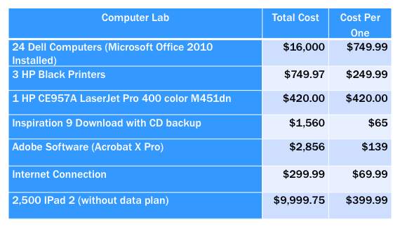
We requested a total of $30,000 to advocate the plan above. The majority of funds will go towards new resources such as the iPad 2. Additional funds may be added to cover monthly professional development training. We also request an additional 10% to cover any other finances.

