Using Apple Configurator

iPad Volume Purchasing Program 2012-2013

Table of Contents

Introduction………………………………………………………………………………………………… 3

First Time Mac Users – Tips & Tricks……………………………………………………………………..3

Getting Started……………………………………………………………………………………………….4

What is Apple Configurator?.........................................................................................................................4

Accessing Apple Configurator………………………………………………………………………………5

How to Check For Software Updates……………………………………………………………………….6

Creating Groups to Match Profiles…………………………………………………………………………7

How to Add Applications to Different Groups……………………………………………………………..8

Assigning iPads……………………………………………………………………………………………….9

How to Download Free Applications………………………………………………………………………11

Adding Free Applications to Apple Configurator………………………………………………………...12

Introduction

This document was created by the MIS Department to aid in training of the Apple Configurator Application. It should only be in the possession of iPad Managers and Site Directors. If iPad Managers subject to change, please contact the MIS Department.

First Time Mac Users – Tips & Tricks:

Track Pad(Mouse Pad)

As you have probably noticed, there is no “right-click” button on a Mac. However, by hitting “Control” on the keyboard and clicking at the same time, you can generate a “right-click” option. Since the Track Pad is very sensitive(as certain finger swipes and movements can trigger commands), it is important that when using it you are firm and careful.

Keyboard Shortcuts

On a Windows machine, we often use Ctrl-C to Copy, Ctrl-V to Paste, Ctrl-A to Select and many more keyboard shortcuts using the Control key. You can do these same functions with a Mac by select Command and a letter. For an example, Command-C to Copy, Command-V to Paste or Command-A to Select.

The Dock

On a Mac, your Windows Start Task Bar is what’s known as “The Dock.” Here is where you will find most of your applications.

Closing Windows and Applications

Typically on a Windows machine, when closing a window or program, we select the red X located in the top right corner. For a Mac, hitting the red X may close a program on your screen but it will still continue to run. You can permanently close a program on a Mac by one of the following ways: 1. Control-Click on the Application Icon located in the dock and select “Quit,” or when running the Application, to exit hit “Command-Q.”

Force Quit

When a program freezes on you, there is no “Control-Alt-Delete” option on a Mac. For this, we use “Force Quit.” Force Quit can be accessed by hitting “Command-Alt-Escape.” This will bring up the Force Quit dialog which is similar to Windows Task Manager.

Getting Started:

1. Upon turning on your MacBook Pro, you will come to a log on screen that will look like this:

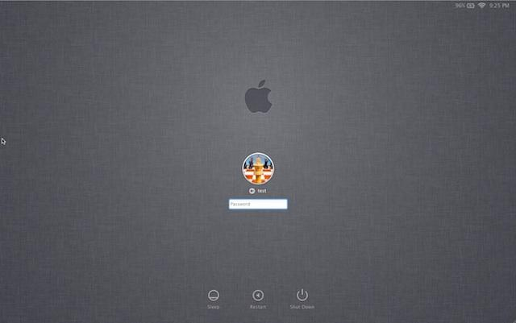

Please enter your log-in credentials based on your site. If you have forgotten your log-in credentials, please contact MIS.

After logging on, please select the Apple Configurator icon which is located in the dock on the bottom of the screen.

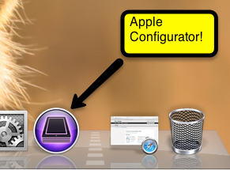

What is Apple Configurator?

Apple Configurator is an application made to manage the deployment of a large number of iOS devices, such as iPhones or iPads.

Accessing Apple Configurator:

Apple Configurator is an application made up of three components: Prepare, Supervise and Assign. Upon entering Apple Configurator, you will be brought to the Prepare Screen. Please ignore the Prepare Screen and click on the “Supervise” section of Apple Configurator located on the top-center of the screen.

Please Note: The “Prepare” section of Apple Configurator is to only be configured by the MIS Department. DO NOT click on any options within the Prepare section. This may result in data loss, iPad restores and serious disruptions within iPad Management.

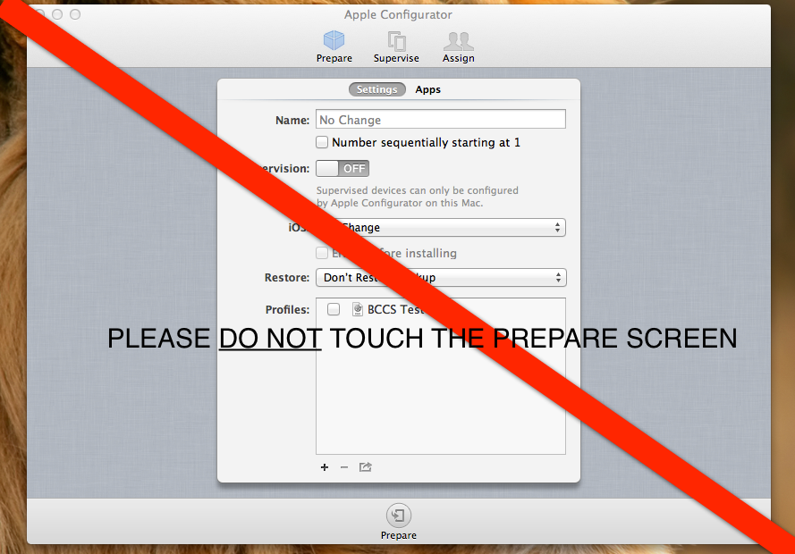

How To Check For Software Updates:

Figure 1  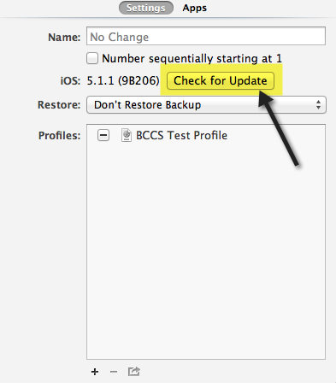 | Please click the “Check for Update” button located under the “Supervise” tab of Apple Configurator as shown in Figure 1. If there is an update, you will come across a screen like this:  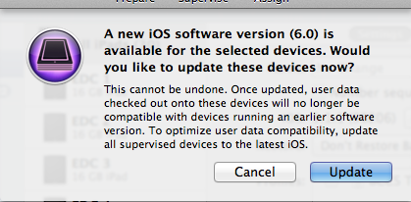  Please click “Update” in order to install the most recent software available for iOS devices.

After clicking “Update,” make sure to select the “Apply” button located at the bottom of the screen. This will apply the Update to all iOS devices(iPads). Be sure to select “All iPads,” when making changes to every iPad at once. Figure 2 below indicates the location of the “Apply” button with a red circle.

Figure 2
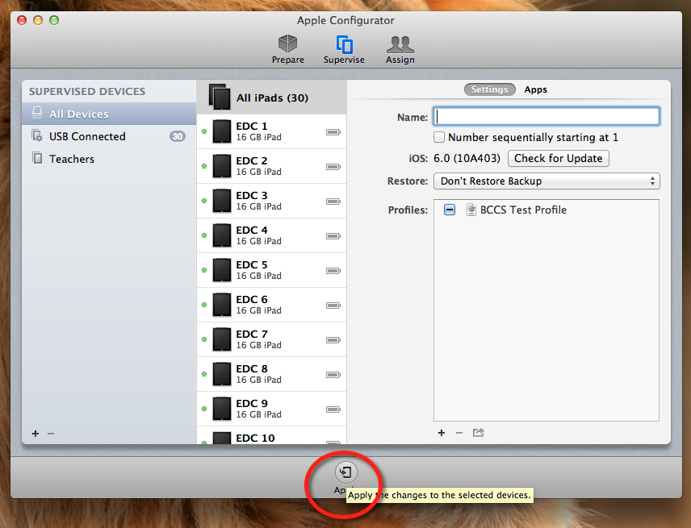

Creating Groups to Match Profiles:

A “profile” on the Apple Configurator is a configuration of restrictions and security settings that will be applied to each iPad. These restrictions will be determined by the Director of each site and the iPad Committee. Profiles will only be created by the MIS Department.

A “group” on the Apple Configurator is an accumulation of similar applications and restrictions. For an example, a group called “Classroom iPads,” may contain a collection of five iPads that are under the “Classroom Profile,” which restricts them from using Safari and FaceTime. However, a group called “Therapists,” may contain a collection of ten iPads that are under the “General Profile,” that permits Safari and FaceTime. Each group has its own applications but can be individualized per user if need be.

In order to create a group, go to the Supervise Page of Apple Configurator. Select the “ + “ symbol at the bottom left-hand corner of the screen as shown in the figure on the left. Use this to add as many groups as necessary.

After creating your groups, hold down “Command+Shift” and click on the select iPads you want to select per each group. Once the desired amount of iPads are highlighted, drag them into the select group. Repeat this process as needed.

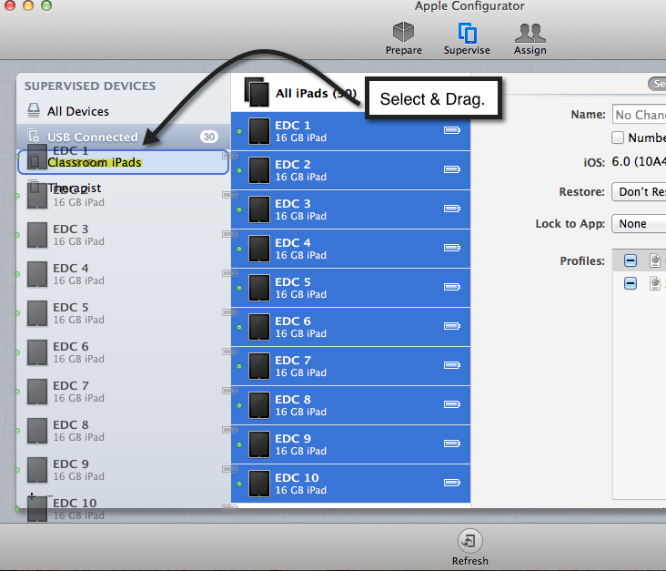

When configuring a profile to a group, make sure you have both the group and the iPads you want to configure, selected. If you want to apply the restrictions to the whole group, make sure that “All iPads” is selected. Then check off the profile of restrictions you wish to apply. Please refer to the demonstration below:

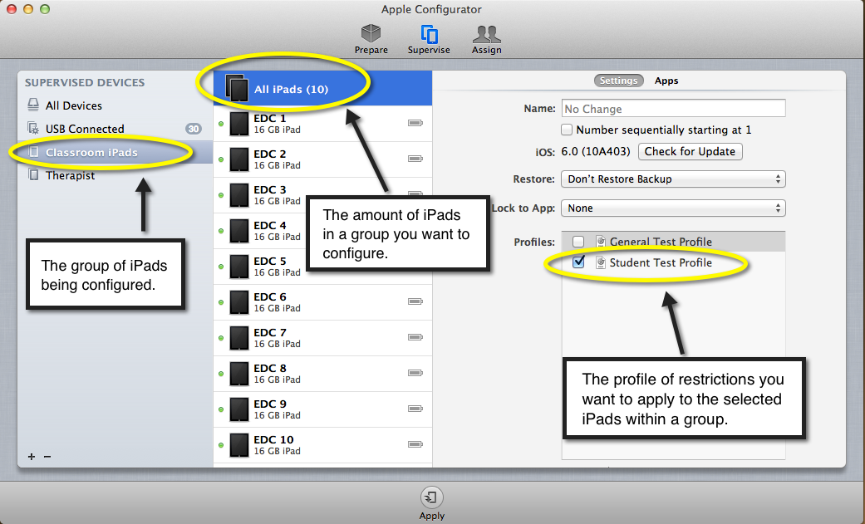
Once you have selected the iPads you want to configure, select “Apply” to add these changes. To change or modify a group profile, deselect the original profile, select the new profile and click “Apply.”

How to Add Applications to Different Groups:

Within the “Supervise” screen, click “Apps” located on the right hand side of the screen.

When adding applications to different groups, make sure you have both the group, the iPads you want to configure and the application(s) you want, selected. If you want to apply applications to the whole group, make sure that “All iPads” is selected. If you only want to apply the application to one iPad, select the specific iPad you want to configure. Please refer to the demonstration below:

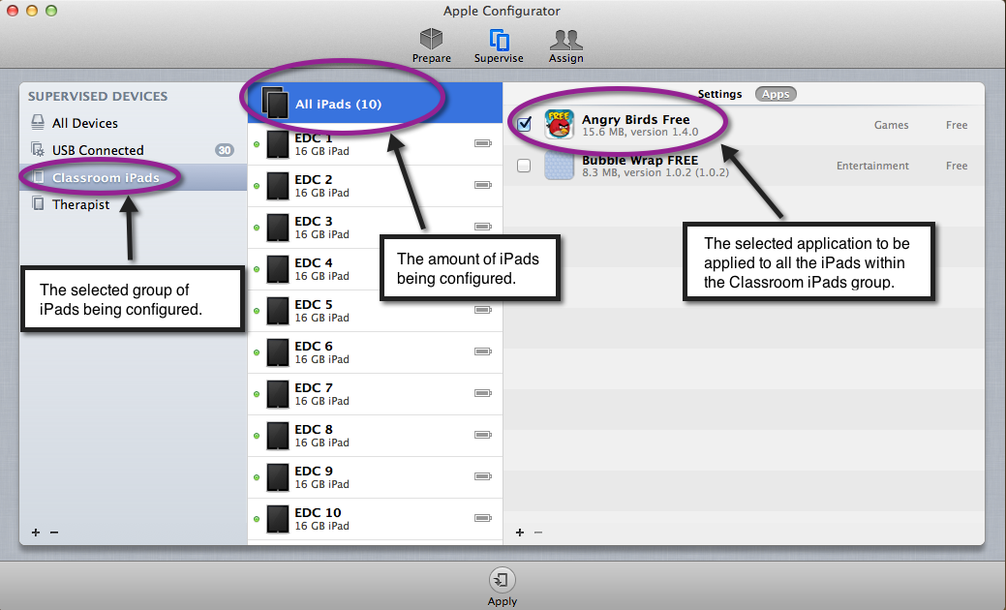

Once you have selected the iPads you want to add the application(s) to, select “Apply” to add these changes.

Assigning iPads: Checking In and Checking Out:

To check in and out iPads, click the “Assign” section of Apple Configurator. There you can create User Groups and Personal Users. User Groups can be named the same as groups used in the “Supervise” section of Apple Configurator(i.e. Classrooms, Therapists, Teachers, etc.). Personal User creation may vary based upon User Groups. For an example, if one of your user groups is named “Classrooms,” your users may be called “Classroom 1, Classroom 2, Classroom 3.” To create a User Group, click the “ + “ at the bottom left corner of the left column. To create Users, click the “ + “ located at the bottom left of the middle column. Please refer to the images on the next page for guidance.

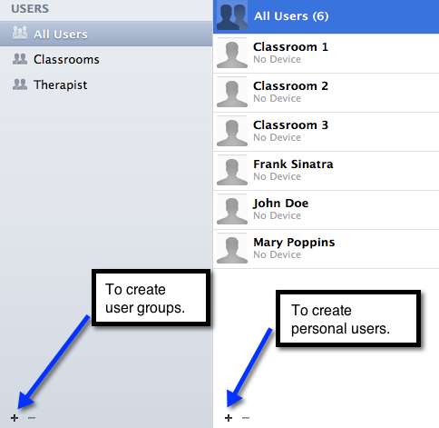  To put personal users into user groups, use “Command+Shift” to select the personal users you want for each user group. Once they are selected, drag them into the user group you  want to place them in. Then click “Check Out.” | Once you click “Check Out,” you will be brought to the screen below where you will be able to assign iPads to each user.  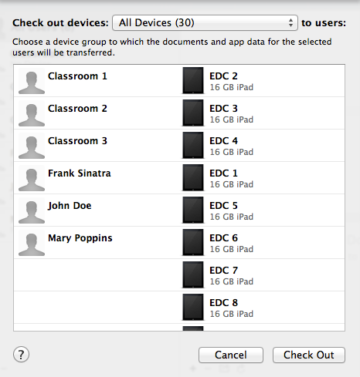  To assign different users to different iPads, just move each iPad by dragging and dropping them next to the user whom you want to assign it to. By clicking “Check Out,” your devices will quickly update any applications added or new software, and then will be ready for use.

Once you “Check Out” your devices, you will notice that the button on the bottom of Apple Configurator now says “Check In.”
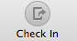
Upon return, it is important that you select “Check In” for these devices so that they can be synchronized. During synchronization, the iPads will backup any data they retain and any new configurations within the Apple Configurator application.

How to Download Free Applications:

**Please Note: All Applications MUST BE APPROVED by the Director of each site before downloading. All PAID applications must be downloaded by the MIS Department only.

To download a free application, start by clicking the icon for iTunes located in the dock on the bottom of the screen. Upon entering, make sure you’re signed in with your sites Apple ID and password. If you do not know these credentials, please contact the MIS department. | 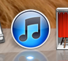

Once iTunes is open, select “iTunes Store,” located on the left-hand side of the screen as shown in Figure 3. Then select “Apps,” located on the top center of the iTunes screen as shown in Figure 4 below.

Figure 3 Figure 4
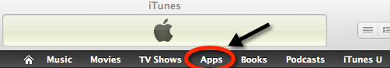
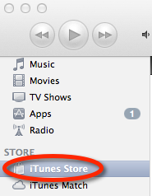

When browsing for an application, you can search by clicking the different categories provided on the right-hand side of the screen. To look for an application by name or keyword, you can type your search credentials in the spotlight box. Spotlight is located at the top right-hand corner of the iTunes screen and usually says “Search Store.” Make sure you are browsing iPad Applications and not iPhone Applications.

Once you have decided on an application you would like to download, click the “free” button located next to the application. The application will download into a folder within iTunes. | 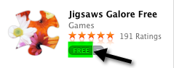

Adding Free Applications to Apple Configurator:

To add a free application to the Apple configurator, begin by going to the “Supervise” screen. On the right hand side, click “Apps,” located next to Settings.

Then proceed by clicking the “ + “ symbol on the bottom left of the screen as demonstrated in the picture below:

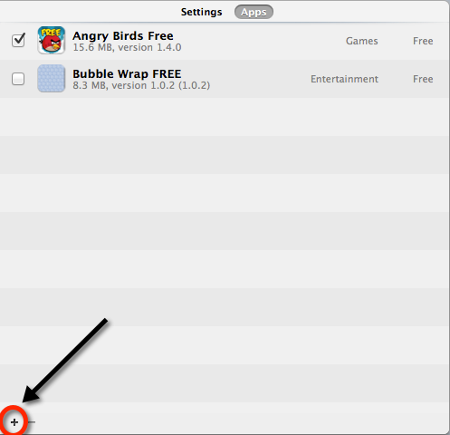

You will then be brought to the “Finder” screen. In order to add an application, you can search for it by name in Spotlight located in the upper right hand corner of the screen. Or you can do it manually by following the steps below:

Please Note: The names and location of these files and folders below may vary based upon your site.

1. Select “Music” located in the scroll-screen on the left.
2. Click the “iTunes” folder.
3. Click the “iTunes Media” folder.
4. Click “Mobile Applications folder”
5. Select your application.

Once your application is imported, select the group of iPads you wish to deploy it too. If you wish to only deploy it to one iPad, select the device name. If you wish to apply it to all iPads, select “All iPads” or “All Devices.” Once selected, hit “Apply” located at the bottom center of the screen.

